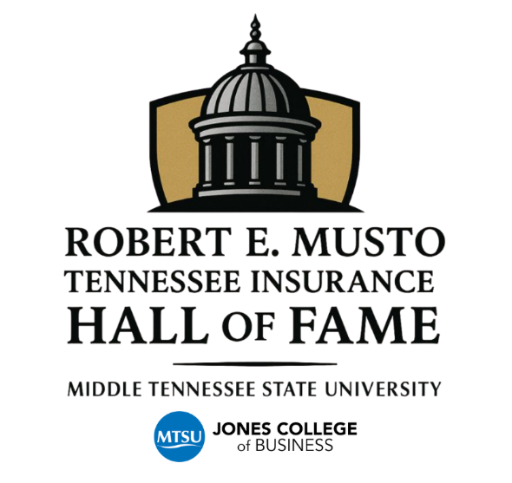

NOMINATION APPLICATION
Use this Word document as your application. Please complete each question below, and as you enter information, the document will expand as needed. The selection committee requests succinct, objective, and verifiable information. Applicants may attach additional letters of support or supplemental documentation, if applicable.
While not required, we strongly request that a photo (preferably professional and high quality) be submitted along with the application. Obtaining photos of inductees after the selection process created challenges in prior years and resulted in delays related to announcements, engraving, printed programs, and the running slideshow during the ceremony.
Please provide your responses in a bullet (versus paragraph) format for each question and save your completed Word document. Email the completed application, along with any attachments and a photograph of the nominee, to TNInsHoF@mtsu.edu no later than Friday, April 10th, 2026.
Nomination Criteria
The nominee must have served in the risk and insurance industry in the state of Tennessee for at least 20 years, demonstrating distinction and integrity in one or more of the following capacities:

- Insurance broker or agent
- Risk advisor
- Risk manager
- Actuarial science professional
- Insurance industry entrepreneur or executive
- Claims adjuster
- Captive management professional
- Insurance instructor or professor
- Insurer underwriter or representative
- Health and benefits consultant or advisor
- Life insurance or wealth advisory professional
- Technology or software development related to insurance functions

Nomination Questions
1. Describe the nominee’s achievements in leadership, such as mentoring others, inspiring high performance, or creating an environment in which individuals were able to reach their career goals.

2. Describe accomplishments, if applicable, as a sales producer who consistently exceeded sales targets over time through exceptional service and by recognizing the importance of their team in the process.

3. Describe the nominee’s contributions as a subject matter expert who drove innovation through product or service development, authored original research or publications, or served as a respected speaker or educator.

4. Describe how the nominee consistently demonstrated professionalism and acknowledged the value of every team member.

5. List industry-related designations or advanced degrees related to the insurance sector and, when applicable, describe adherence to continuing education requirements.

6. Describe the nominee’s volunteer efforts and leadership positions with non-profit organizations, education or mentoring efforts, and participation in insurance industry-related outreach programs. Include service on professional boards, pro bono advising, and efforts to increase insurance literacy.

7. Describe the nominee’s civic and community service efforts, including leadership or participation in charitable and nonprofit initiatives, service to underserved populations, disaster relief, community board memberships, that advanced the public good. Include key events or initiatives in which the nominee led or participated.

8. Describe how the nominee fostered a spirit of giving within their organization or inspired others to become more involved in their communities.

